SEO Optimization

Definition
# Source: AI Source: Provided by: [Data Path: Persons Table -> ID Column: 1, Name_En Column: Motasem Essam] -> From: [Chatgpt (GPT‑5 Mini)] on [2/12/2026]
SEO Optimization (Search Engine Optimization) is a web design technique used to improve a website’s visibility in search engines like Google so that it appears higher in search results.

Simple Definition
# Source: AI Source: Provided by: [Data Path: Persons Table -> ID Column: 1, Name_En Column: Motasem Essam] -> From: [Chatgpt (GPT‑5 Mini)] on [2/12/2026]
SEO Optimization = improving a website so people can find it easily on search engines.

How SEO Optimization Works
# Source: AI Source: Provided by: [Data Path: Persons Table -> ID Column: 1, Name_En Column: Motasem Essam] -> From: [Chatgpt (GPT‑5 Mini)] on [2/12/2026]
• Using relevant keywords in content and headings
• Optimizing page titles and meta descriptions
• Creating high-quality and useful content
• Improving website speed and performance
• Using proper headings (H1, H2, H3)
• Optimizing images (alt text, size)
• Building internal and external links

Purpose of SEO Optimization
# Source: AI Source: Provided by: [Data Path: Persons Table -> ID Column: 1, Name_En Column: Motasem Essam] -> From: [Chatgpt (GPT‑5 Mini)] on [2/12/2026]
• Increase website traffic
• Improve search engine ranking
• Make content easier to find
• Attract the right audience
• Increase visibility and online presence

Advantages
# Source: AI Source: Provided by: [Data Path: Persons Table -> ID Column: 1, Name_En Column: Motasem Essam] -> From: [Chatgpt (GPT‑5 Mini)] on [2/12/2026]
• More organic (free) traffic
• Better visibility on search engines
• Improves user experience
• Helps build trust and credibility
• Long-term marketing benefits

Disadvantages
# Source: AI Source: Provided by: [Data Path: Persons Table -> ID Column: 1, Name_En Column: Motasem Essam] -> From: [Chatgpt (GPT‑5 Mini)] on [2/12/2026]
• Takes time to see results
• Requires continuous updates and effort
• Can be complex to learn and apply
• Search engine algorithms change frequently
• Competitive keywords can be difficult to rank for
• Requires consistent content creation

Examples
# Source: AI Source: Provided by: [Data Path: Persons Table -> ID Column: 1, Name_En Column: Motasem Essam] -> From: [Chatgpt (GPT‑5 Mini)] on [2/12/2026]
• A website appearing on the first page of Google results
• Using keywords like “best web design techniques” in content
• Adding alt text to images for search engines
• Writing blog posts to attract visitors
• Optimizing page speed for better ranking

Difference Between SEO Optimization and Other Techniques
# Source: AI Source: Provided by: [Data Path: Persons Table -> ID Column: 1, Name_En Column: Motasem Essam] -> From: [Chatgpt (GPT‑5 Mini)] on [2/12/2026]
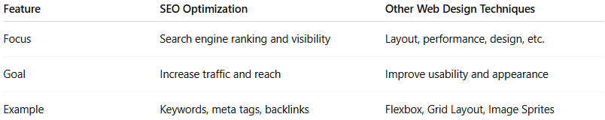
Feature | SEO Optimization | Other Web Design Techniques
Focus | Search engine ranking and visibility | Layout, performance, design, etc.
Goal | Increase traffic and reach | Improve usability and appearance
Example | Keywords, meta tags, backlinks | Flexbox, Grid Layout, Image Sprites

